GENERAL PURPOSE REGISTERS (GPRs)

The CPU's Workbench

Think of the CPU as a worker. **Registers** are the worker’s hands or small workbench.

They hold the tools and materials (data, addresses, pointers) the CPU needs right now.



I. Why they matter:

Registers give the CPU instant access to information.

Without them, the CPU would waste time going back and forth to RAM (the big library) or the Hard Drive (the warehouse).

II. How they work:

The CPU can’t use RAM directly. It must first copy data into a register.

Once in a register, the CPU can add numbers, compare values, or move data quickly.

III. Key Points:

* **Location:** Inside the CPU chip.
* **Speed:** Extremely fast — one cycle vs. hundreds for RAM.
* **Volatility:**

The 32-bit Registers

In this modern x86 architecture, we have eight special types of registers called general-purpose registers (GPRs). Each of these GPRs is a single 32-bit block. This is different from the earlier 16-bit registers that were used in older CPU models.



I. Breaking Down Each Register

Let's explore each register and its typical uses:

1. **AX**: Used for addressing data, pointing to specific locations.
2. **BX**: Similar to AX, used for addressing data, but often used for larger values (like 16-bit numbers).
3. **CX**: Often used for addressing data in addition to what's already stored in AX and BX.
4. **DX**: A bit different from the others, it's usually set by the program or hardware to point to a specific address.
5. **BP**: Used for storing addresses of previously loaded data (or code).
6. **SP**: This register holds the stack pointer, which is used to manage memory and return values.
7. **SI** (or **DI**): Usually linked to BP, SI stores the base address of a block of memory.
8. **EAX**, **EBX**, **ECX**, **EDX**: These registers are like AX, BX, CX, and DX, but with 16-bit widths instead of 32 bits.

So, in short, these eight registers provide direct access to your CPU's data storage locations, making them incredibly useful for efficient program execution.

In the x86 architecture, registers have grown over time. Intel maintained backward compatibility, meaning the names tell you the size.

* **8-bit (1970s):** AL, AH, BL, etc.
* **16-bit (1980s):** AX, BX, CX. (The "X" usually stands for pair or extended from 8-bit).
* **32-bit (1990s):** EAX, EBX, ECX. (The **"E"** stands for **Extended**).
* **64-bit (2000s):** RAX, RBX, RCX. (The **"R"** stands for **Register** or Re-extended).

*Note: In this chapter, we focus on the 32-bit "E" registers, as they are the standard baseline for malware analysis and reverse engineering.*

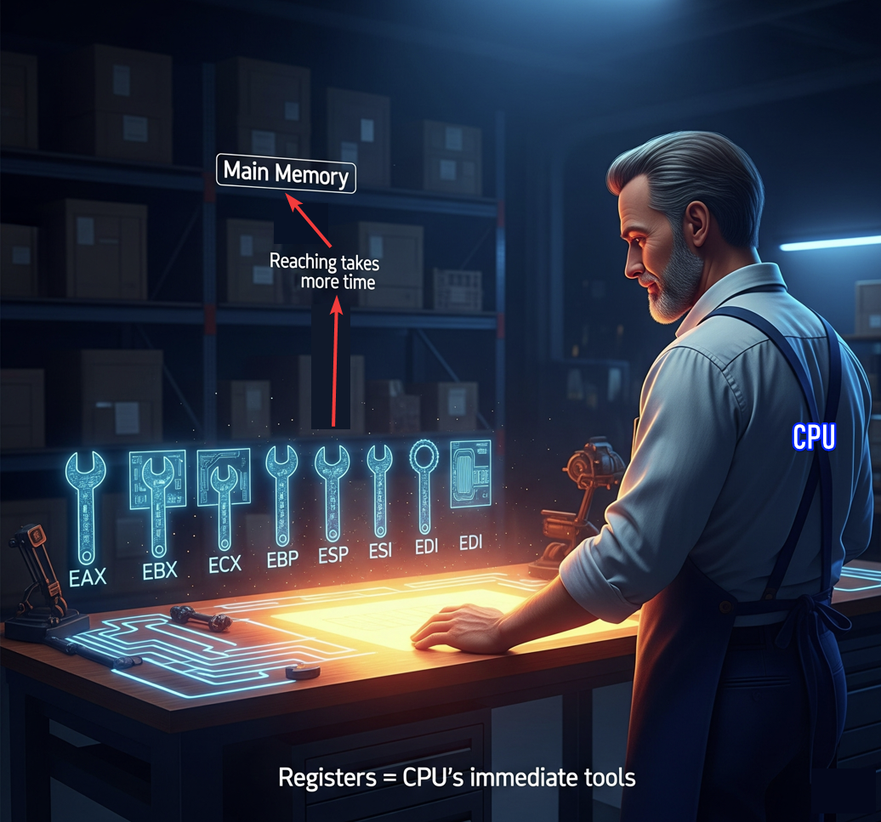

II. The Multi-Role Power Tools

The general-purpose registers in x86 are not just simple scratchpads. They're actually **multi-role power tools** that handle various tasks, such as data, pointers, counters, parameters, addresses, and even system calls.

Think of them like a set of versatile hammers, each one capable of performing different functions. For example:

* **AX** is for moving data - it can be used to load, store, or manipulate data in various locations.
* **BX** is similar to AX, but often used for *larger values* or *addressing higher memory* locations.
* **CX** is another type of register that's often used in addition to AX and BX.

III. Gaining Muscle in Protected Mode

In **protected mode (32-bit),** the general-purpose registers grew stronger and more powerful.

The first eight registers **AX to DI** became **EAX to EDI**, which are like a new set of tools with 16-bit widths instead of the original 8-bit width.

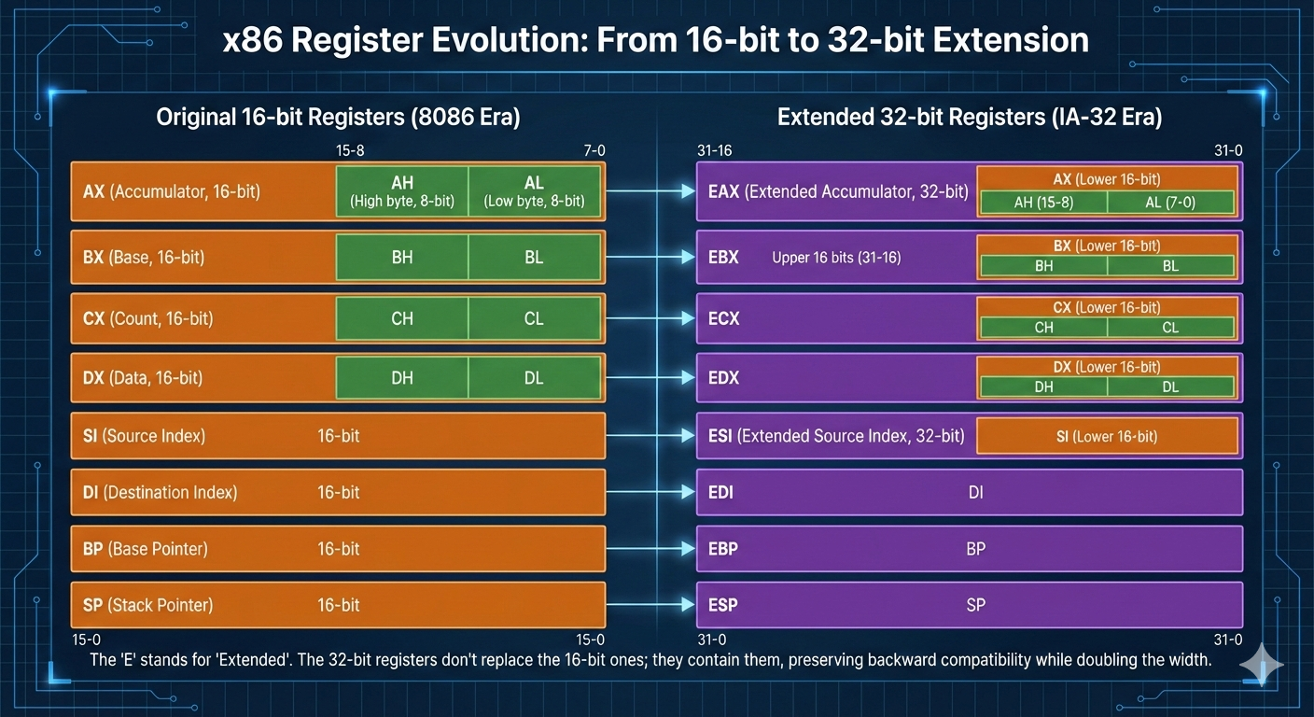

Later, in long mode (64-bit), even more registers were added:

* RAX to RDI: This is another "set of 8" with increased functionality.
* R8 to R15: These additional registers bring the total count to 16, providing a wider range of operations and tools for your CPU.

It's worth noting that these multi-role power tools are not just used in x86 processors; they're also found in other architectures, such as ARM and PowerPC.

3.2 The Core Four: Arithmetic & Logic

These four registers—EAX, EBX, ECX, and EDX—are special because they can be split into smaller pieces.

This comes from very early x86 designs in the 1970s, but it’s still useful today.

It lets the CPU work with single bytes, like characters in a string, instead of always handling full numbers.

I. EAX

EAX is mainly used for math and logic.

Most calculations end up here, and the CPU is optimized to use it fast.

When a function finishes running, its return value is placed in EAX.

Because of this, programs often check EAX right after a function call to see if something succeeded or failed.

For example, after a password check, the code might look at EAX to see if the result was 1 or 0.

EAX can be split into smaller parts: AX is the lower 16 bits, and that can be split again into AH (high 8 bits) and AL (low 8 bits).

II. EBX

EBX is commonly used to hold a base address in memory.

Think of it as pointing to where some data starts, like the beginning of an array or structure.

Older code used EBX heavily for memory access, but modern compilers don’t give it a strict role anymore.

Because of that, it’s often used as a general-purpose register to store values that need to stay around for a while. Like EAX, it can be split into BX, BH, and BL.

III. ECX

ECX is mostly used as a counter.

The CPU relies on it for loops, especially when repeating an instruction multiple times.

There’s even a special LOOP instruction that automatically decreases ECX by one each time it runs.

When copying or moving data in chunks, ECX usually holds how many bytes or items need to be processed. ECX can also be split into CX, CH, and CL.

IV. EDX

EDX is often used as a helper register for EAX. When multiplying or dividing large numbers, the result may not fit in EAX alone, so the CPU uses EDX together with EAX to hold the full result.

EDX is also commonly used in input and output operations, such as storing port addresses. Like the others, it can be split into DX, DH, and DL.



3.3 The Index Registers

ESI and EDI are used when the CPU is moving data in memory.

This usually means copying arrays, strings, or blocks of bytes from one place to another.

You’ll see them a lot in code that handles buffers and string operations because they’re built to do this kind of work fast.

I. ESI - Extended Source Index

Holds the address of the data being read.

It points to where the data starts, like the source of a copy.

When the CPU is moving bytes, it reads them from the memory location stored in ESI.

II. EDI – Extended Destination Index

Holds the address of where the data is being written. It points to the destination, where the copied data will end up. As the CPU copies each byte, it writes it to the address in EDI.

You can think of it like moving stuff from one place to another. ESI is the old place where the boxes are, EDI is the new place, and the CPU walks back and forth moving things from ESI to EDI.

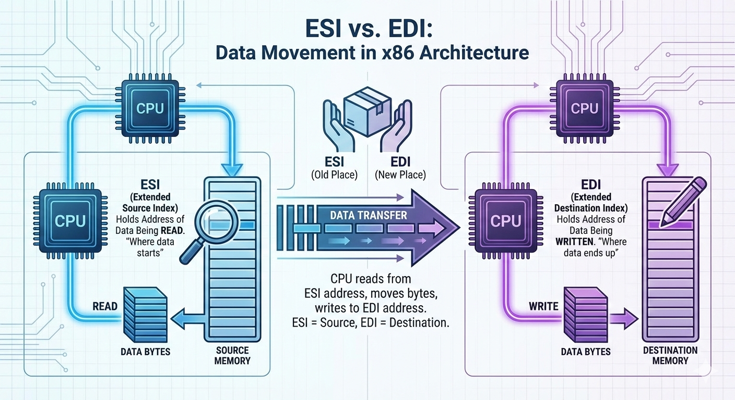

3.4 The Pointer Registers (The Stack)

ESP and EBP are used to manage the stack. These registers are extremely important, and you normally don’t use them for math or random storage.

If they get messed up, the program will usually crash because the CPU no longer knows where the stack is.

I. ESP – Extended Stack Pointer

Always points to the top of the stack.

When a value is pushed onto the stack, ESP moves downward to make space.

When a value is popped off, ESP moves back up.

The CPU constantly updates ESP as the program runs, so it is always changing.

Because of this, you generally should not manually change ESP unless you are writing very low-level code like a compiler or an operating system.

II. EBP – Extended Base Pointer

Used as a stable reference point for a function.

When a function starts, EBP is set to mark the base of that function’s stack frame and then stays mostly the same while the function runs.

This is important because ESP keeps moving as values are pushed and popped.

By using EBP, the program can reliably access local variables and function parameters using fixed offsets, like **“EBP minus 4”** or **“EBP plus 8.”**

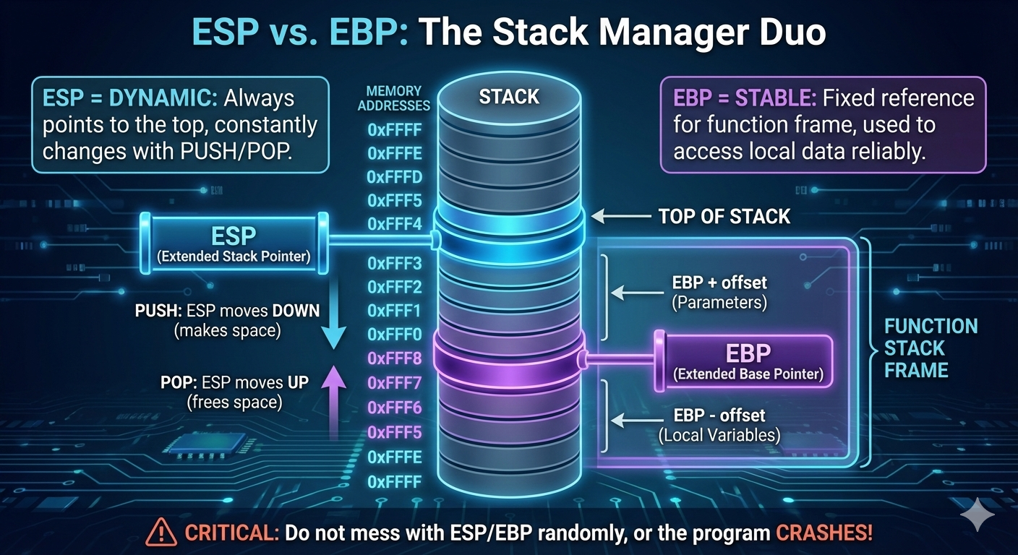

3.5 Register Breakdown Table (32-bit Architecture)

Visualizing how the registers overlap is crucial. Remember: Changing AL **changes** EAX. They are the same physical wires.

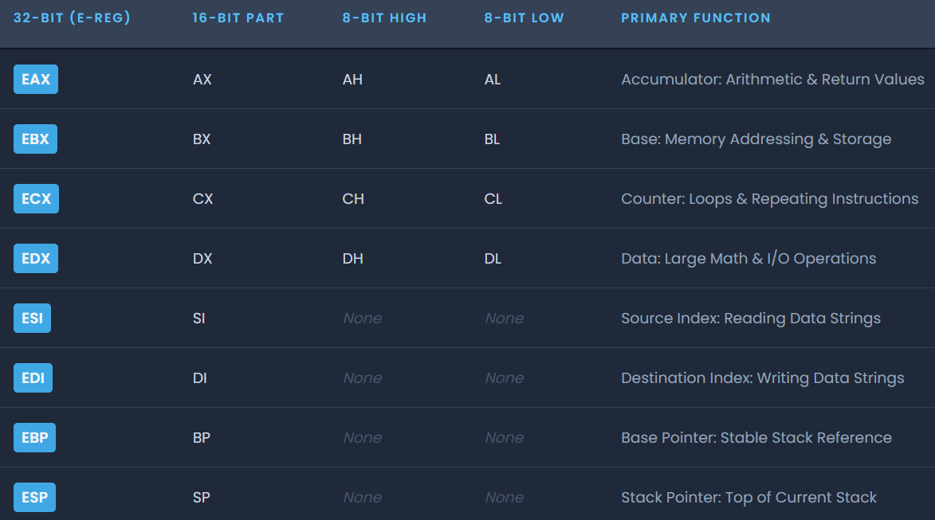

3.6 Reverse Engineering Insight: Register Slicing

Even in a 64-bit world, the small pieces of registers like AL and AH still matter.

A lot of real code works on bytes, not full 32-bit or 64-bit values.

Characters in strings, for example, are only 8 bits, so when a program checks a password one character at a time, it compares the value in AL against a single byte like 0x41 for the letter 'A', not the entire EAX register.

This also shows up in malware and obfuscated code.

Some malware avoids detection by building values one byte at a time using 8-bit registers.

Since many antivirus signatures look for known 32-bit patterns, assembling instructions byte-by-byte can help malicious code slip past simple pattern matching.

There’s also a practical performance reason.

Using smaller registers can reduce instruction size and sometimes be slightly more efficient.

Compilers and hand-written assembly will still use 8-bit operations when they make sense.

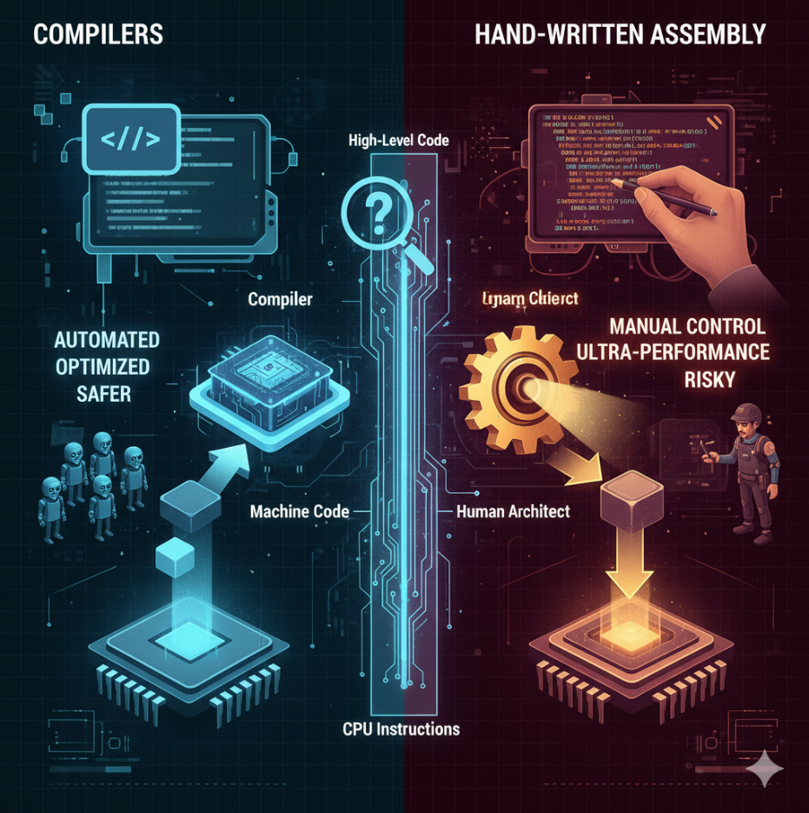

3.7 Chapter Review

If EAX contains the value 0x12345678, the lower 16 bits are stored in AX, so AX would be 0x5678.

The lowest 8 bits are stored in AL, which would be 0x78.

You can’t access a “high” or “low” 8-bit part of registers like ESI or EDI because only the core registers (A, B, C, and D) were designed with addressable 8-bit sub-registers.

Registers like ESI, EDI, EBP, and ESP must be accessed as 16-bit or 32-bit values.

When a function finishes running, its return value is placed in EAX.

If you want to know whether a function succeeded or failed, that’s the register you check.

SPECIAL PURPOSE REGISTERS (x86) **🧩⚙️**

1.1 What “Special Purpose” Really Means

Special-purpose registers are registers that exist to **control the CPU itself**, not just to hold random data. They:

* Control **execution flow**
* Control **memory access**
* Track **CPU state**
* Enable **debugging, protection, and task switching**

Unlike general-purpose registers:

* Some of them **cannot be freely used**
* Some are **invisible to normal programs**
* Some can crash the system if misused

Think of them as: *“The steering wheel, brakes, and dashboard of the CPU”*

You don’t casually play with them.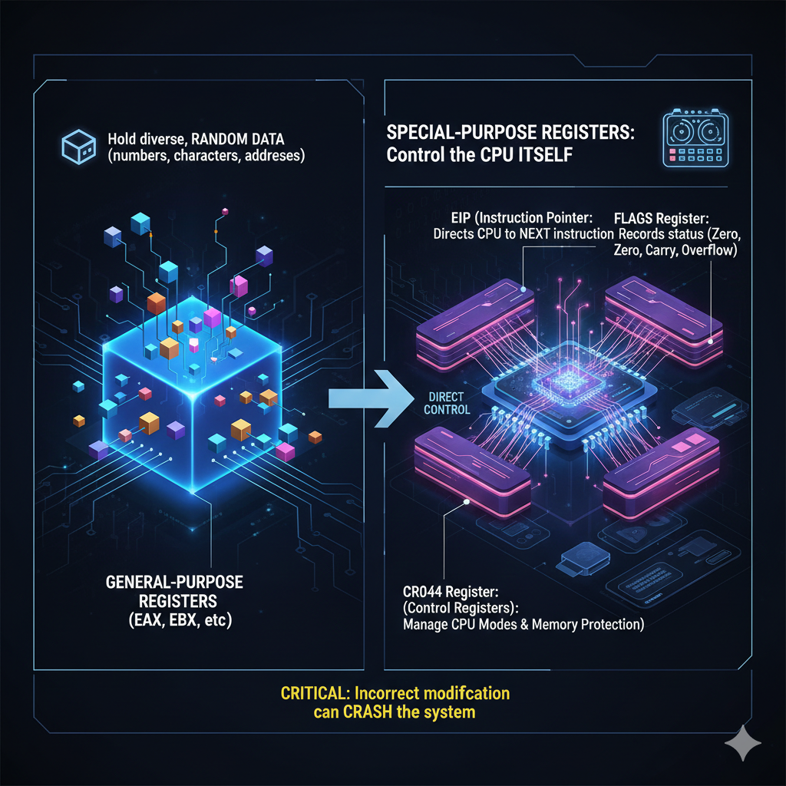

1.2 Instruction Pointer (IP / EIP) **🧭**

**What it is**

The **Instruction Pointer** holds the memory address of the **next instruction** the CPU will execute.

* 16-bit mode → IP
* 32-bit mode → **EIP**
* 64-bit mode → RIP

You almost never write to EIP directly.

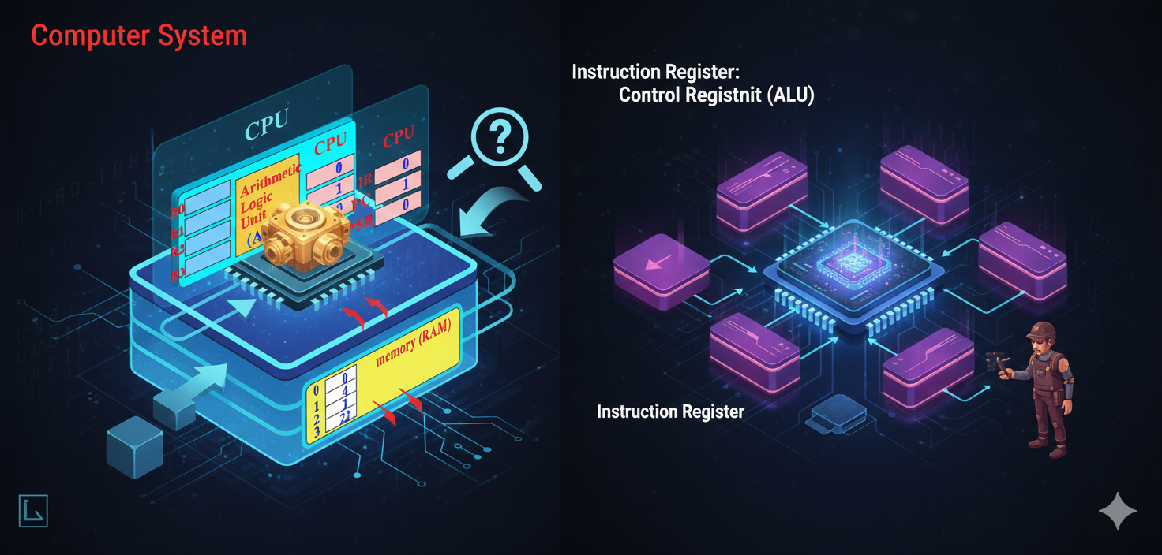

Instead, it changes through:

* JMP
* CALL
* RET
* Interrupts
* Exceptions

Example mental model:

EIP is the CPU’s “you are here” arrow.

If you control EIP:

* You control **execution**
* You control **program flow**
* You own the process

This is why exploits aim to:

**Overwrite EIP**

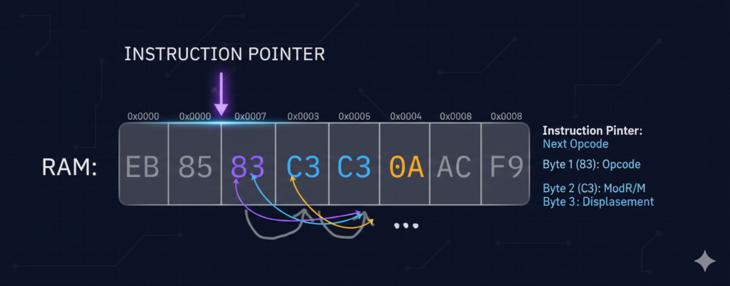

1.3 Flags Register (FLAGS / EFLAGS) **🚦**

**What it is**

The Flags Register stores **status bits** describing what just happened in the CPU.

After arithmetic or logic:

* Was the result zero?
* Was there a carry?
* Was there an overflow?
* Was the result negative?

Common flags:

* ZF → Zero Flag
* CF → Carry Flag
* OF → Overflow Flag
* SF → Sign Flag

Example:



CMP does **not** jump.  
It only sets flags.

JE checks:

“Is ZF = 1?”

Flags are the **decision-makers** behind conditional jumps.

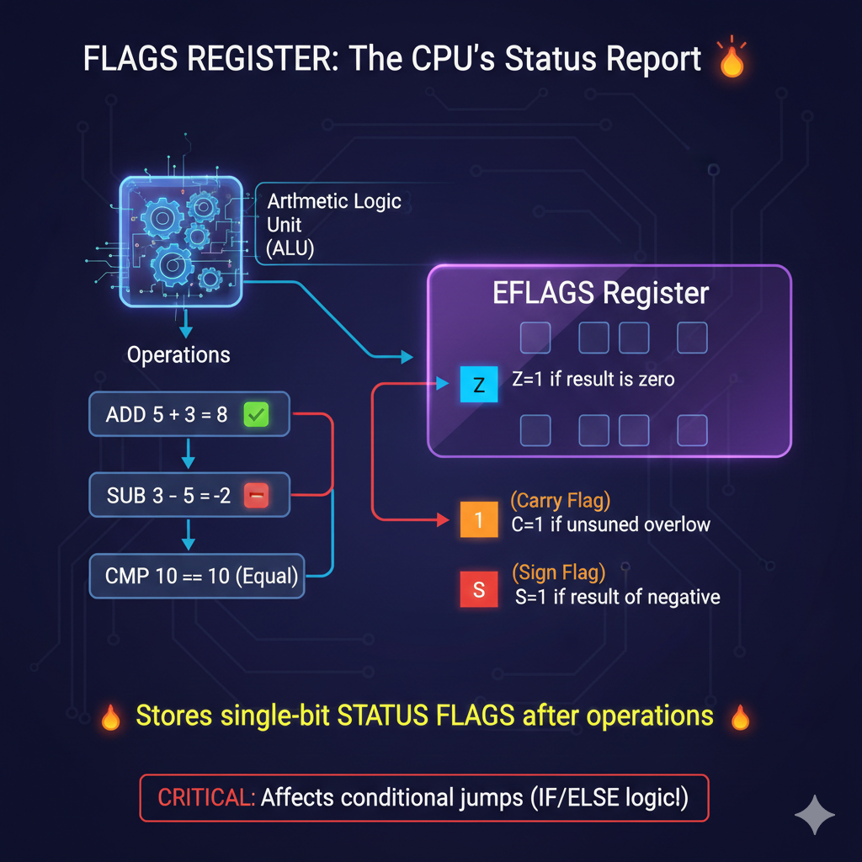

1.4 Stack Pointer (SP / ESP) **📦**

**What it is**

ESP always points to the **top of the stack**.

The stack is used for:

* Function calls
* Return addresses
* Local variables
* Saved registers

Key rules:

* PUSH → ESP decreases
* POP → ESP increases

ESP is automatically modified by the CPU.

Important:

ESP is both **general-purpose in theory** and **special-purpose in reality**

You *can* use it as a normal register.  
You *shouldn’t* unless you’re advanced.

Corrupt ESP → corrupted execution.

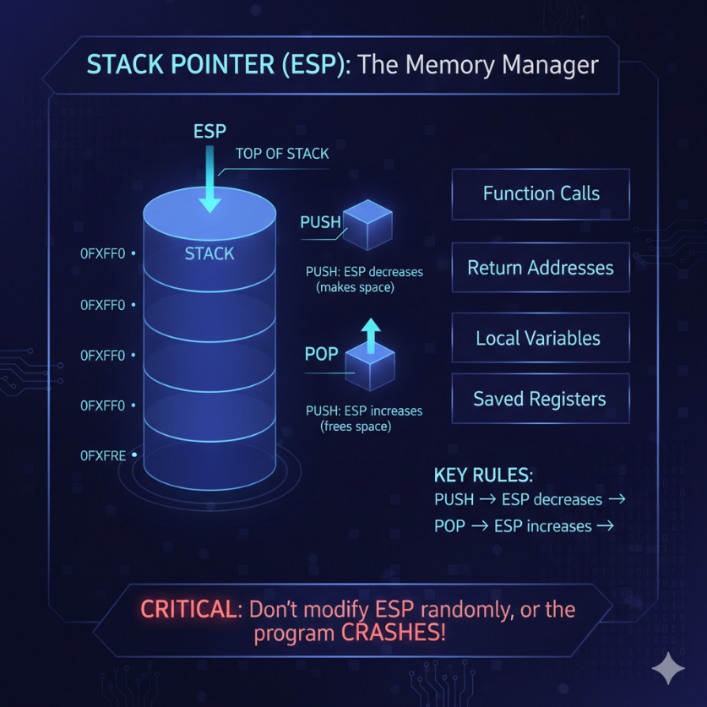

1.5 Base Pointer (BP / EBP) **🧱**

**What it is**

EBP points to the **base of the current stack frame**.

It provides:

* Stable access to function arguments
* Stable access to local variables

Unlike ESP:

* EBP usually stays fixed during a function

Example:



Why debuggers love EBP:

* Stack frames become readable
* Call chains become visible

Why optimizers remove it:

* One less register used
* Faster code

So yes:

EBP is special-purpose **by convention**, not by force.

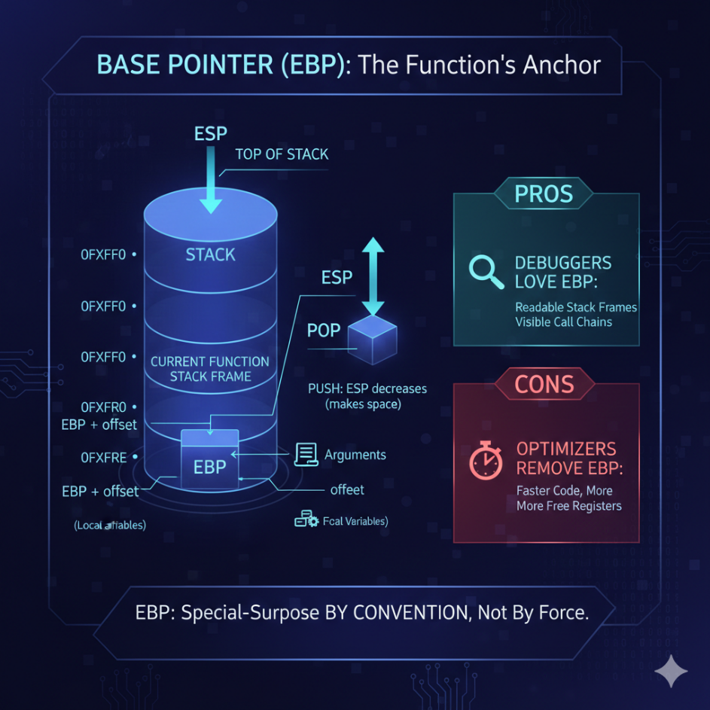

1.6 Index Registers (SI, DI, ESI, EDI) **🔁**

**What they are:** Index registers are optimized for **string and array operations**. They shine in:Memory copying, Memory comparison and Buffer processing.

Roles:

* ESI → Source Index
* EDI → Destination Index

Used by instructions like:

* MOVS
* CMPS
* LODS
* STOS
* SCAS

With REP + ECX: The CPU becomes a **hardware memory mover**. This is why malware loves them.

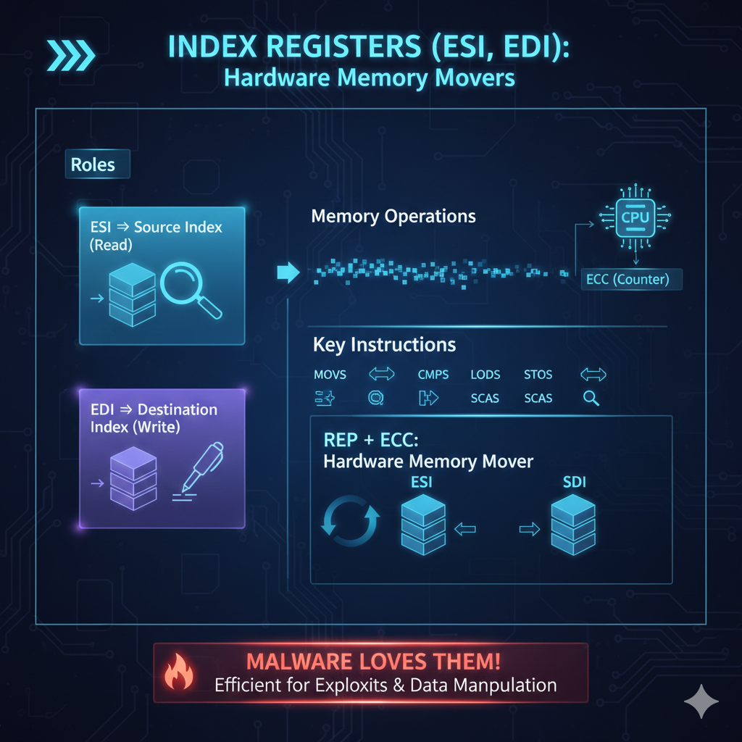

1.7 Segment Registers (CS, DS, SS, ES, FS, GS) **🧠🧱**

**What they are**

Segment registers define **which segment of memory** you are accessing.

Historically:

* Memory was divided into segments
* Each segment had a base address

Key ones:

* CS → Code Segment
* DS → Data Segment
* SS → Stack Segment

Modern systems:

* Segmentation is mostly hidden
* Paging dominates

But:

* FS / GS are still heavily used
* Thread-local storage
* OS internals
* Malware tricks

Segment registers are **not obsolete** — just less visible.

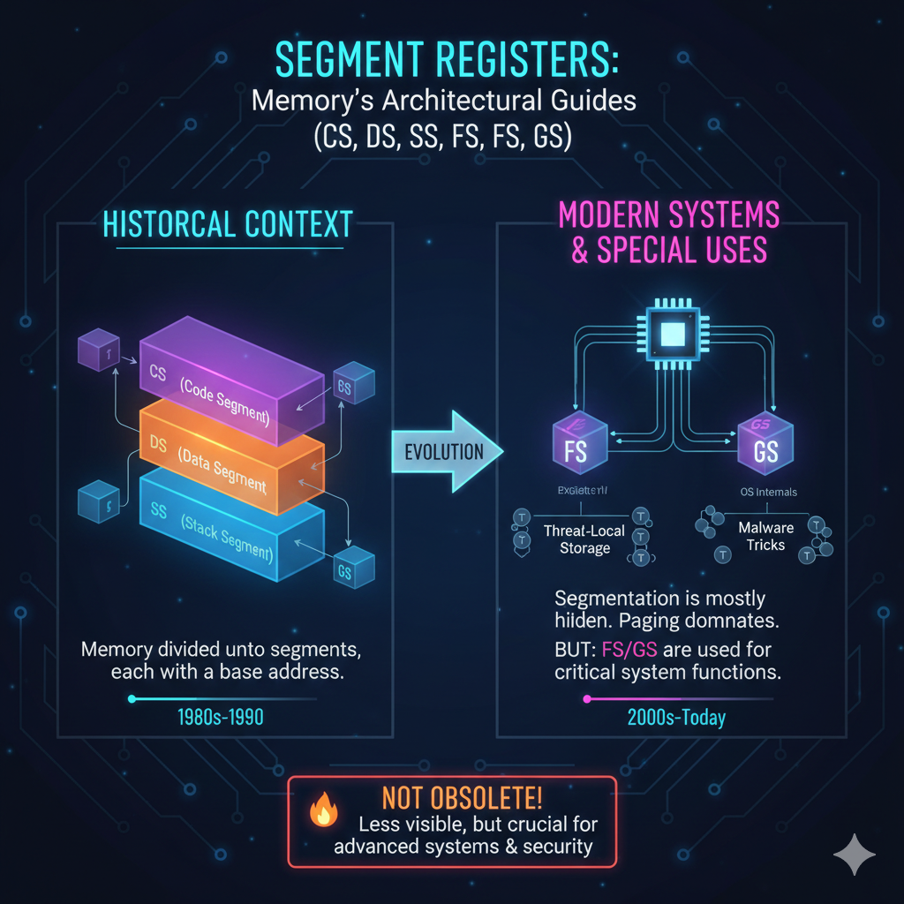

1.8 Control Registers (CR0, CR2, CR3, CR4, CR8) **🔐**

**What they are**

Control registers define **how the CPU operates**.

They control:

* Protected Mode
* Paging
* Virtual memory
* Write protection
* Supervisor/User mode behavior

Examples:

* CR0 → enables protected mode
* CR3 → holds page directory base
* CR2 → stores faulting address (page fault)

Normal programs **cannot touch these**. Only kernel-mode code can.

These registers separate the user code from the operating system

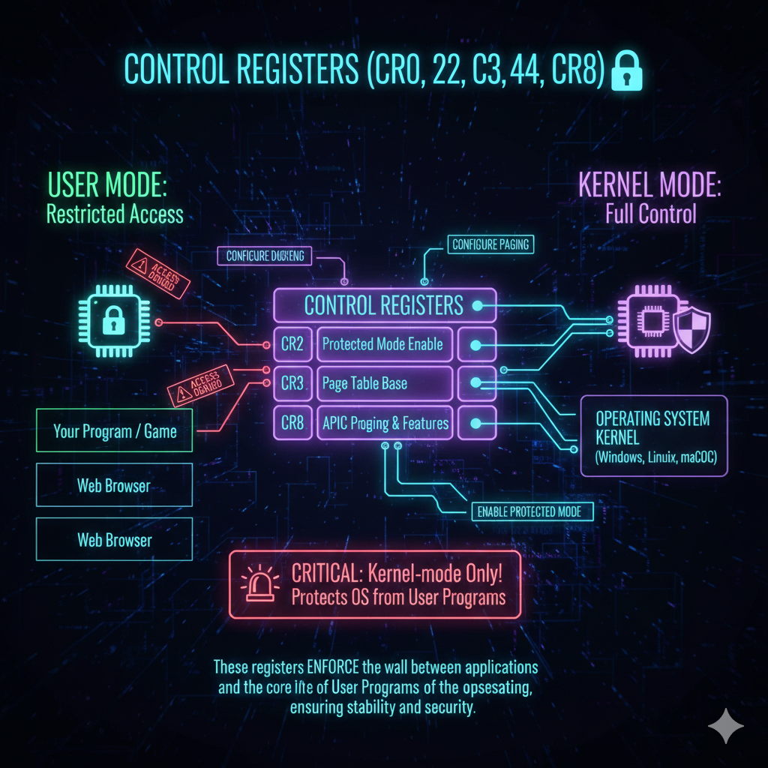

1.9 Debug Registers (DR0–DR7) **🐞**

**What they are:** Hardware debugging registers.

They allow:

* Breakpoints on memory access
* Breakpoints on execution
* Monitoring without code modification

Used by debuggers, anti-debugging checks and malware evasion.

Malware often:

* Detects DR registers
* Clears them
* Behaves differently if debugging is detected

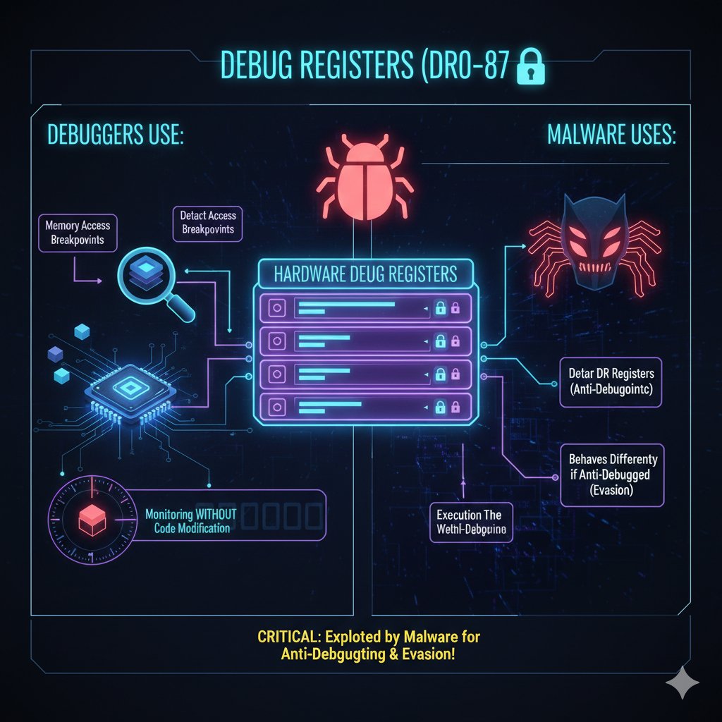

1.10 Model-Specific Registers (MSRs) **🧪**

**What they are**

CPU-vendor-specific registers.

Used for:

* Performance counters
* Power management
* Feature toggles
* Security extensions

Accessed using: **RDMSR** and **WRMSR**

Highly privileged.  
Highly dangerous.  
Highly powerful.

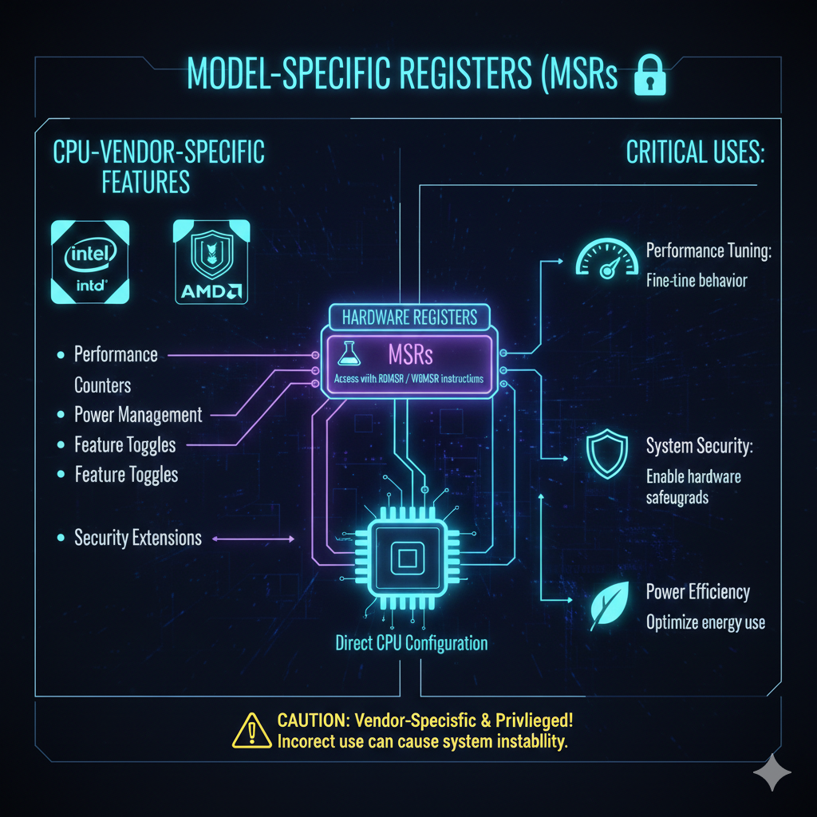

1.11 Task Register (TR) **🔄**

**What it is**

The Task Register points to the **Task State Segment (TSS)**.

Used in:

* Hardware task switching (mostly legacy)
* Interrupt stack switching
* Privilege transitions

Modern OSes:

* Rarely use full hardware task switching
* Still rely on TSS for interrupts

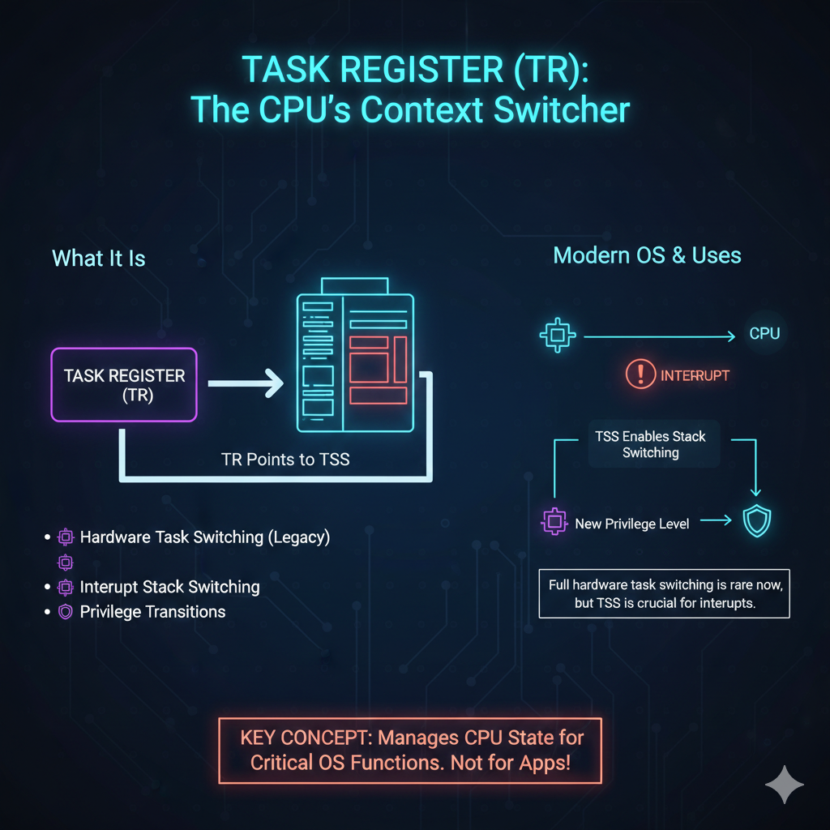

1.12 Local Descriptor Table Register (LDTR) **📋**

**What it is**

LDTR points to the **Local Descriptor Table**.

LDT:

* Defines per-task memory segments
* Used in protected mode

Mostly historical, but:

* Still exists
* Still relevant in deep OS internals

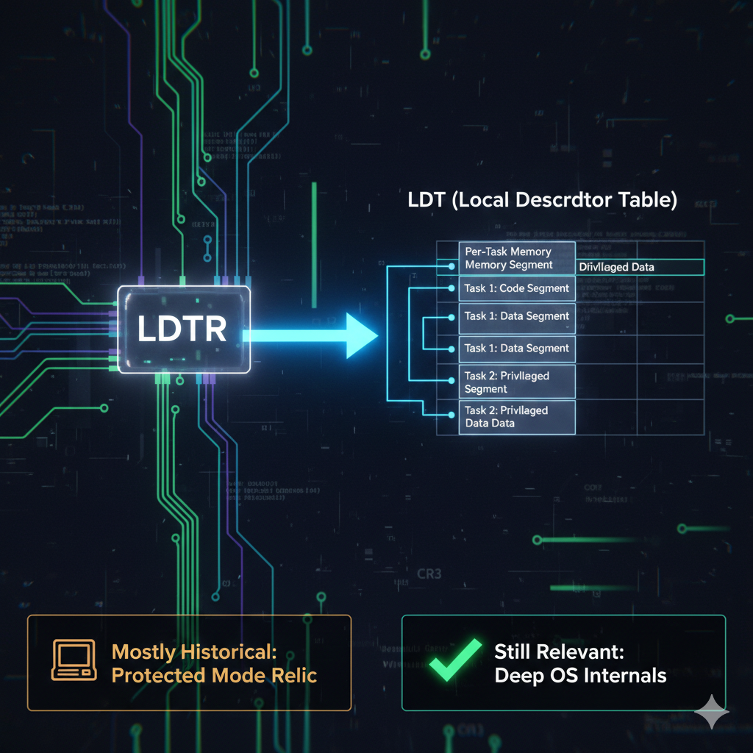

1.13 The ESP / EBP “Double Identity”

**ESP** and **EBP** live in two worlds at the same time. At the hardware level, they are just general-purpose registers.

The CPU doesn’t magically protect them or force special rules on how they’re used. In theory, you *could* use them like any other register.

In practice, they have special meaning because of convention. Compilers, debuggers, and operating systems all expect ESP to track the stack and EBP to describe the current stack frame. When code follows these conventions, tools work correctly and stack traces make sense.

When those conventions are broken, everything starts to fall apart. Debuggers lose track of variables, stack walking fails, and even simple analysis becomes confusing or impossible.

Registers like EAX or EBX don’t have this problem. They are just containers for data and have no built-in structural role. ESP and EBP are different because they don’t just hold values — they describe the shape of the program’s execution. That’s what gives them their “double identity.”

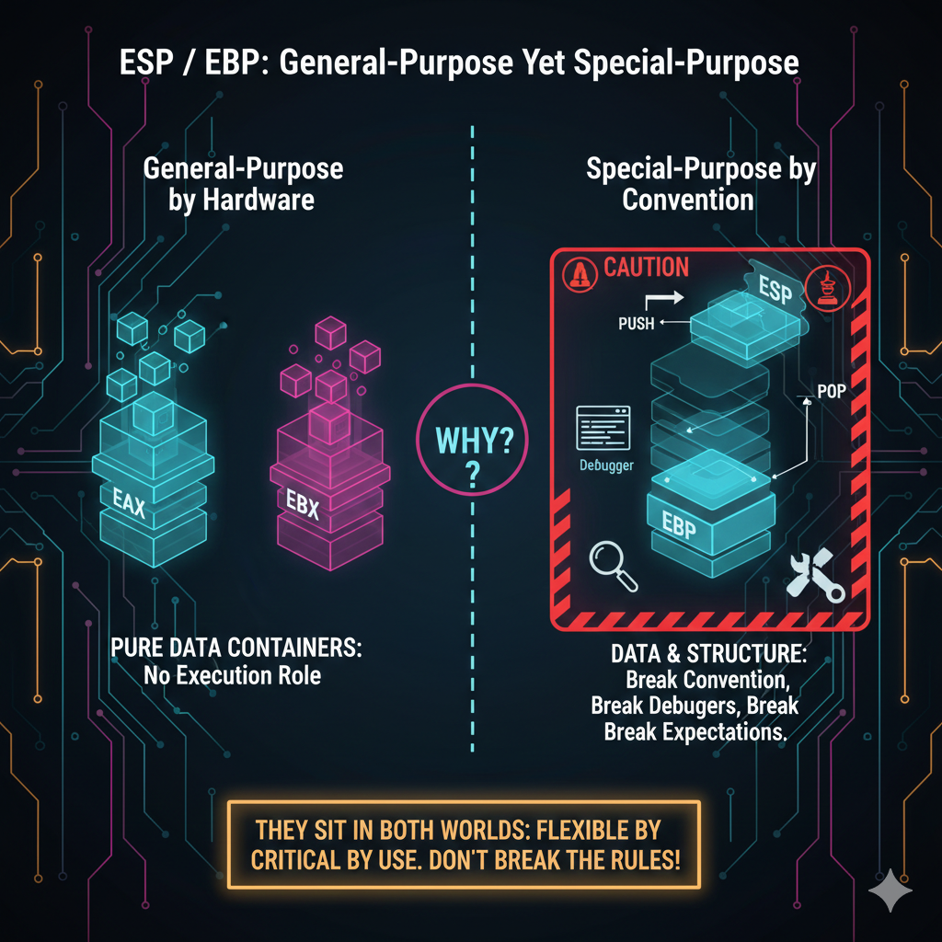

1.14 “E”, “R”, and the Evolution of Register Names

Register names changed as CPUs grew wider over time. Originally, registers like AX were 16-bit and used in early real-mode systems.

When x86 moved to 32-bit protected mode, those same registers were extended, and an **E** was added to the name. That’s where EAX comes from — the **E** simply means *extended*.

Later, when 64-bit CPUs were introduced, the registers were extended again and given an **R** prefix instead. AX became RAX, and the same pattern applies to the other core registers.

Because of this, the prefix on a register name tells you a lot at a glance. It hints at the CPU generation, the execution mode the code is running in, and the size of the values the register can hold.

Once you know that, the naming scheme stops feeling arbitrary and starts feeling very deliberate.

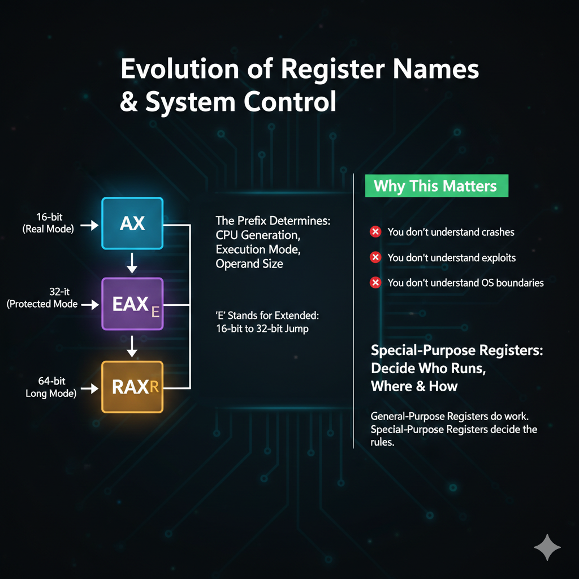

1.15 Why This Chapter Matters

If you don’t understand special-purpose registers:

* You don’t understand crashes
* You don’t understand exploits
* You don’t understand OS boundaries

These registers:

Decide *who* runs, *where*, and *how*

General-purpose registers do work.  
Special-purpose registers **decide the rules**.

SEGMENT REGISTERS (x86) **🧠🧱**

2.1 Why Segment Registers Exist (Historical Truth)

Segment registers exist because early x86 CPUs could **not directly address large memory**.

Instead of one flat address space, memory was divided into **segments**:

* Code lived in one place
* Data lived in another
* Stack lived somewhere else

Segment registers were created to:

Extend addressing power  
Add basic memory protection  
Organize program memory

Even though modern systems hide segmentation, the **concept still lives inside the CPU**.

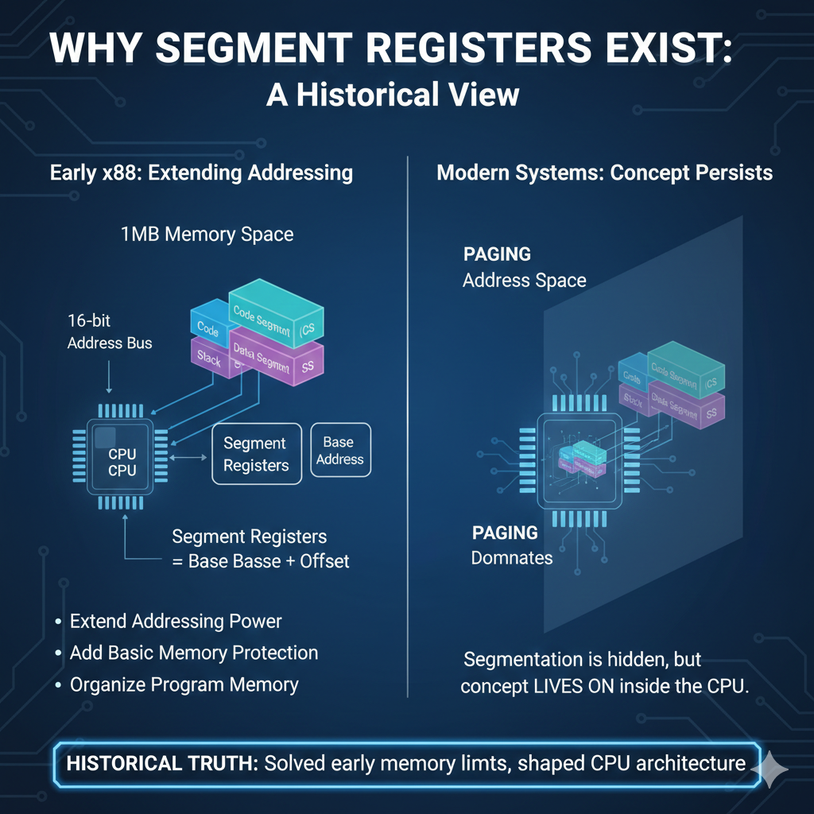

2.2 What Segment Registers Actually Hold

Segment registers **do not hold raw memory addresses** (in modern modes).

They hold **segment selectors**.

A **segment selector** is a small value that:

* Points to an entry in a table
* That entry describes a memory segment

**Think of it like this:** Segment register → index → descriptor → real memory info

So:

* Segment register = “which segment?”
* Descriptor = “where is it and what are the rules?”

2.3 Segment Registers in Real Mode (16-bit World)

In **real-address mode**:

* Segment registers are **16 bits**
* They directly represent memory segments

Registers used:

* CS → Code Segment
* DS → Data Segment
* SS → Stack Segment
* ES → Extra Segment

**Address calculation:** Physical Address = Segment × 16 + Offset

**Example:** CS = 0x1234 and IP = 0x5678

**Physical Address:** 0x1234 × 16 + 0x5678

This is:

* Simple
* Fast
* Unsafe
* No real protection

This is why real mode is called **real-address mode**.

2.4 Protected Mode: Segments Become Descriptors **🔐**

In **protected mode**, everything changes.

Segment registers:

* Still exist
* Still matter
* But no longer point directly to memory

Instead, they hold **selectors** that reference:

* Global Descriptor Table (GDT)
* Local Descriptor Table (LDT)

Each descriptor defines:

* Base address
* Limit (size)
* Access rights
* Privilege level

So, the CPU now says:

*“Before I touch memory, check the rules.”*

This is where **protection** comes from.

2.5 The Six Segment Registers in Protected Mode

Protected mode uses **six segment registers**:

CS — Code Segment

* Points to executable code
* Controls instruction fetch
* Enforces execution permissions

Changing CS:

* Usually requires a far jump or call
* Changes execution context

DS — Data Segment

* Default segment for data access
* Used when reading or writing variables

Most memory instructions implicitly use DS unless overridden.

SS — Stack Segment

* Defines where the stack lives
* Used with ESP / EBP

SS violations:

* Cause immediate faults
* Are tightly protected

ES — Extra Segment

* Additional data segment
* Commonly used with string operations

Often paired with EDI.

FS and GS — Special Purpose Segments 🧵

FS and GS were added later.

**File Segment** or **Fiber/Thread Segment** (used for Thread Information Block/Thread Local Storage).

**General Segment** or **Graphics Segment** (used for CPU-specific data or OS-defined structures in 64-bit Windows/Linux).

They are commonly used for:

* Thread-Local Storage (TLS)
* Per-thread data
* OS internals

Modern examples:

* Windows → FS or GS for TEB
* Linux → GS for per-CPU data

These are **very important in reverse engineering**.

2.6 Base Address and Limit: Memory Boundaries

Each segment descriptor defines:

* **Base** → where the segment starts
* **Limit** → how big it is

Why this matters:

* Access beyond limit → fault
* Access with wrong privilege → fault

This is early memory safety.

Segments enforce:

“You may access THIS memory, and nothing else.”

2.7 Logical Address → Physical Address (Step-by-Step)

When a program accesses memory:



The CPU:

1. Reads DS selector
2. Looks up descriptor in GDT/LDT
3. Gets base address
4. Adds offset (0x1000)
5. Checks limit and permissions
6. Produces linear address

Later, paging may translate that to physical memory

Segments happen **before paging**.

2.8 Modifying Segment Registers **⚠️**

Segment registers can be modified using:

* MOV
* PUSH
* POP

Example:



But important:

Loading a segment register does **not** directly change memory

It triggers:

* Descriptor lookup
* Validation
* Caching inside the CPU

If the selector is invalid:

* General Protection Fault occurs

2.9 Why Changing a Segment Register Feels “Delayed”

When you load a segment register:

* The CPU reads the descriptor
* Stores its info internally
* Uses that cached data for future access

So, memory behavior changes **after descriptor resolution**, not immediately.

This is why:

* Segment changes feel indirect
* Debugging segmentation is tricky

2.10 Segment Registers vs Paging (Modern Reality)

Modern systems:

* Use flat segments (base = 0)
* Rely on paging for protection

But:

* Segment registers still exist
* FS / GS are actively used
* CS still controls privilege

Segmentation is not dead.  
It’s just **quiet**.

2.11 Why This Chapter Matters (ASM + RE Perspective)

If you ignore segmentation:

* You misunderstand OS internals
* You miss TLS tricks
* You misread memory accesses

Segment registers explain:

* Why exploits jump through hoops
* Why kernel/user boundaries exist
* Why certain memory reads behave “magically”

Segments define:

**Where** you’re allowed to be  
**What** you’re allowed to touch

Paging decides *where memory lives*.  
Segmentation decides *who may touch it*.

2.12 Lock-In Questions

1. Why does protected mode use descriptors instead of raw addresses?
2. Why are FS and GS still relevant today?
3. Why does segmentation occur before paging?
4. Why does loading DS not immediately change memory behavior?

INSTRUCTION POINTER (IP / EIP) **🧭🔥**

3.1 What the Instruction Pointer Really Is

The **Instruction Pointer** is the register that tells the CPU:

“This is the address of the next instruction to execute.”

In 32-bit x86:

* The instruction pointer is called **EIP**
* It is **32 bits wide**

Naming across modes:

* Real mode → IP (16-bit)
* Protected mode → **EIP (32-bit)**
* Long mode → RIP (64-bit)

If you understand EIP, you understand **program flow**.

3.2 How the CPU Uses EIP (Fetch–Execute Reality)

Execution follows a simple loop:

1. CPU reads EIP
2. Fetches instruction from memory at EIP
3. Decodes the instruction
4. Executes it
5. Updates EIP to point to the next instruction

Important detail: EIP is **not incremented by a fixed value**

Instruction length varies:

* Some instructions are 1 byte
* Some are many bytes

The CPU figures this out during decoding.

3.3 How EIP Changes Normally

Most of the time, EIP:

* Automatically moves forward
* You never touch it directly

Example:



EIP simply walks forward through memory.

3.4 Instructions That Modify EIP Explicitly **🔀**

Some instructions **change execution flow** by modifying EIP indirectly.

**JMP** is an unconditional jump. When the CPU executes it, it stops following the normal instruction order and loads the target address directly into **EIP**. Execution then continues from that new location, no questions asked.



**CALL** transfers execution to a function. Before the jump happens, the CPU pushes the address of the next instruction onto the stack.

Then it loads EIP with the function’s address. This saved address is what allows the function to return to the correct place when it finishes.



**RET** returns execution to the caller. The CPU pops an address off the stack and loads it into **EIP**. Execution resumes at that location.

If the stack has been corrupted, the value popped is wrong. That means **RET** jumps to a random address, and execution goes straight into chaos.



**INT** triggers a software interrupt, like INT 0x80 in Linux. When the CPU executes it, it automatically changes **EIP** to point to the interrupt handler. The CPU may also switch privilege levels, depending on the interrupt.



3.5 Can You Directly Modify EIP?

No, you can’t just write a value into **EIP** like a normal register:



EIP isn’t a general-purpose register.

You can only change it indirectly — through control-flow instructions like JMP or CALL, through interrupts or exceptions, or by certain hardware events.

This is by design. The CPU protects EIP to make sure program execution stays predictable and safe.

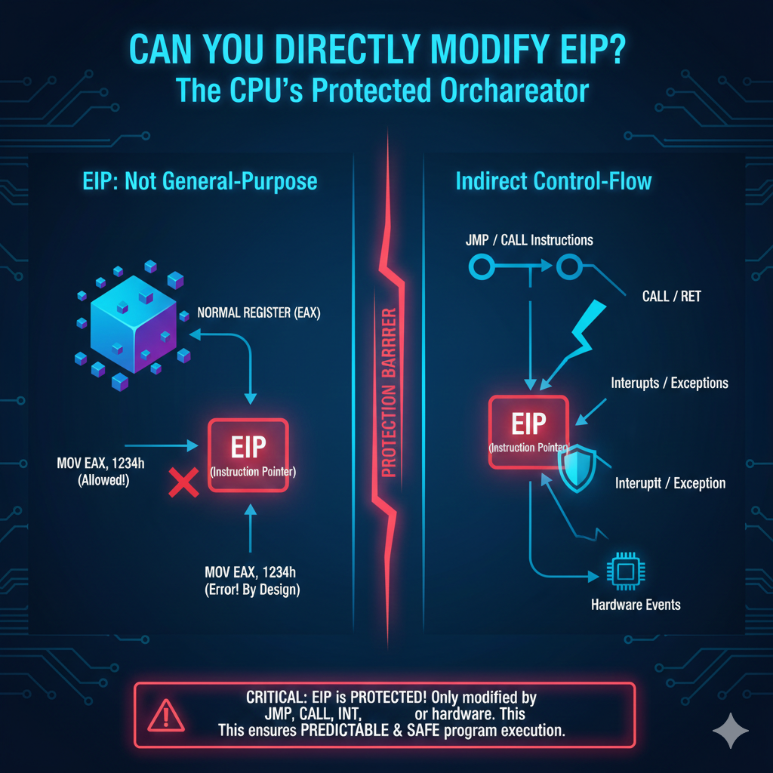

3.6 EIP and EFLAGS Are NOT the Same **❌**

Let’s fix the earlier mistake clearly.

* **EIP** → where execution goes next
* **EFLAGS** → what just happened

They are:

* Separate registers
* Separate purposes
* Updated independently

They work together, but they are not one register.

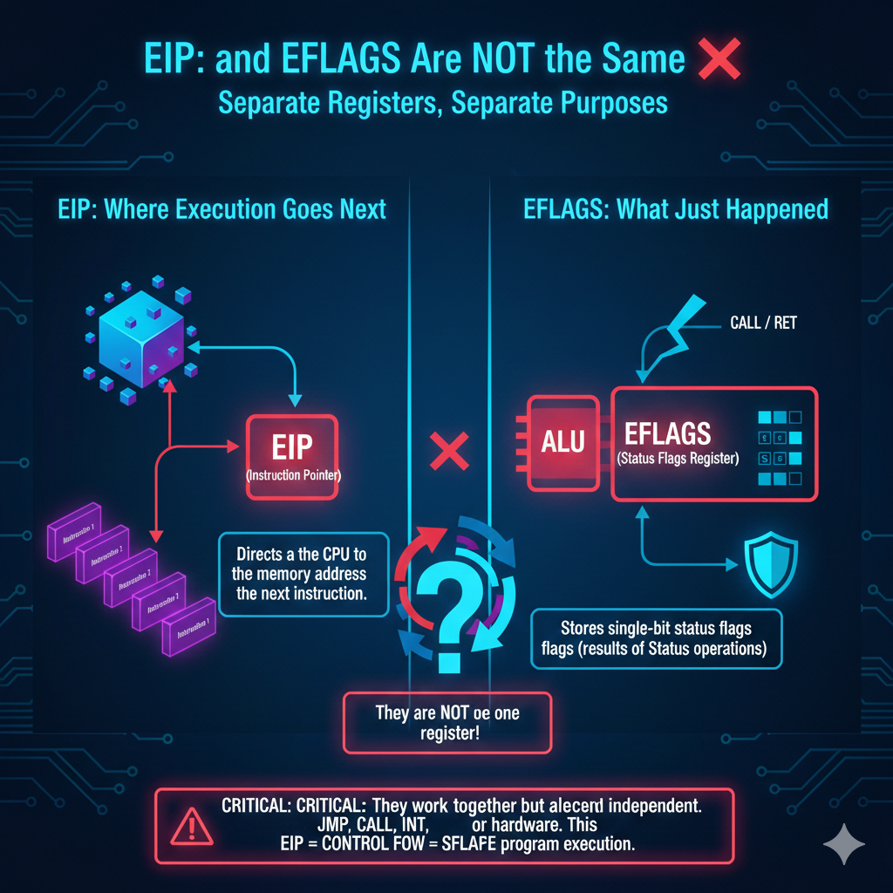

3.7 Why EIP Is the Crown Jewel **👑**

If an attacker controls:

* EAX → they control data
* ESP → they control stack behavior
* **EIP → they control the program**

This is why:

* Buffer overflows target return addresses
* Exploits aim to overwrite EIP
* ROP chains exist

EIP control = **execution control**

3.8 EIP in Reverse Engineering **🔍**

When reversing:

* Watch EIP to understand flow
* Breakpoints trigger on EIP values
* Call graphs are EIP graphs

Debuggers live and breathe EIP.

3.9 What Happens on Crashes

Common crash message: **“Access violation at EIP = 0x41414141”**

That tells you:

* EIP was overwritten
* Execution jumped into junk
* Control flow was hijacked

This is not random. It’s mechanical.

3.10 Summary

EIP:

* Points to the next instruction
* Cannot be written directly
* Is changed only by control flow
* Is the most powerful register in user mode



3.11 Lock-In Questions

1. Why can’t EIP be modified with MOV?
2. How does CALL know where to return?
3. Why is EIP control more powerful than EAX control?
4. Why is instruction length important for EIP updates?

FLAGS REGISTER (FLAGS / EFLAGS) **🚦🧠**

4.1 What the Flags Register Really Is

The **FLAGS / EFLAGS register** is a **32-bit register** that stores small 1-bit values called **flags**.

Each flag answers a question like:

* Did the result become zero?
* Was there a carry?
* Did an overflow happen?
* Should interrupts be handled?
* Should execution pause after each instruction?

Think of EFLAGS as:

The CPU’s **status dashboard + control panel**

It both:

* Reports what just happened
* Controls how the CPU behaves next

4.2 Status Flags vs Control Flags (Clear Separation)

EFLAGS contains **two main kinds of flags**:

**1️. Status Flags (Results of operations)**

These are set automatically by the CPU after math or logic instructions.

**2️. Control Flags (CPU behavior)**

These affect **how the CPU runs**, not math results.

This distinction is important.

4.3 Core Status Flags (Arithmetic & Logic Results)

I. Carry Flag (CF)

Set when:

* An addition produces a carry
* A subtraction produces a borrow

Used for:

* Multi-precision arithmetic
* Unsigned math
* BCD operations

CF answers:

**“Did the operation overflow unsigned range?”**

II. Parity Flag (PF)

Set when:

* The **lowest byte** of the result has an even number of 1 bits

Used historically for:

* Error checking
* Hardware communication

Today:

* Rarely used directly
* Still updated by the CPU

III. Auxiliary Carry Flag (AF)

Set when:

* A carry occurs between bit 3 and bit 4

Used for:

* BCD arithmetic
* Legacy instructions

You’ll mostly see AF in:

* Old code
* Emulators
* CPU internals

IV. Zero Flag (ZF)

Set when:

* Result equals zero

Used constantly for:

* Equality checks
* Loop termination
* Null pointer tests

Example:

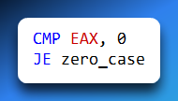

ZF is the backbone of conditional jumps.

V. Sign Flag (SF)

Reflects:

* The most significant bit of the result

If SF = 1:

* Result is negative (signed)

Used for:

* Signed comparisons
* Signed branching

VI. Overflow Flag (OF)

Set when:

* Signed arithmetic exceeds representable range

Example:

* 127 + 1 (8-bit signed) → overflow

OF answers:

“Did this operation overflow **signed** range?”

This is different from CF.

4.4 Control Flags (CPU Behavior Switches) **🔧**

I. Direction Flag (DF)

Controls:

* Direction of string operations

DF = 0:

* Forward (low → high memory)

DF = 1:

* Backward (high → low memory)

Affects instructions like:

* MOVS
* STOS
* CMPS

This flag is often:

* Set intentionally
* Cleared immediately after use

Leaving DF set accidentally causes chaos.

II. Interrupt Flag (IF)

Controls:

* Whether the CPU responds to **external interrupts**

IF = 1:

* Interrupts enabled

IF = 0:

* Interrupts disabled

Used by:

* OS kernels
* Critical sections
* Interrupt handlers

Normal user programs:

Usually cannot freely change IF

III. Trap Flag (TF) **🐞**

TF enables:

* **Single-step execution**

When TF = 1:

* CPU triggers an interrupt after **every instruction**

This is how:

* Debuggers step through code
* Instruction-by-instruction tracing works

Why it’s powerful:

* Complete visibility
* Complete slowdown

Malware may:

* Detect TF
* Clear it
* Alter behavior

4.5 EFLAGS Is Not “One Control Flag” **❌**

There is **no flag called “Control Flag”**.

Instead:

* EFLAGS contains **many independent flags**
* Some control behavior
* Some report status

Calling EFLAGS a *control register* is **conceptual**, not literal.

Precision matters here.

4.6 How Programs Read and Modify Flags

Flags are:

* Set automatically by the CPU
* Read by conditional jumps
* Modified by specific instructions

Examples:

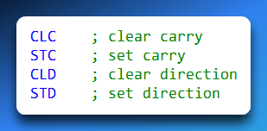

You usually:

* Don’t write flags directly
* Let instructions update them naturally

4.7 Flags and Conditional Branching **🔀**

Most jumps depend on flags:

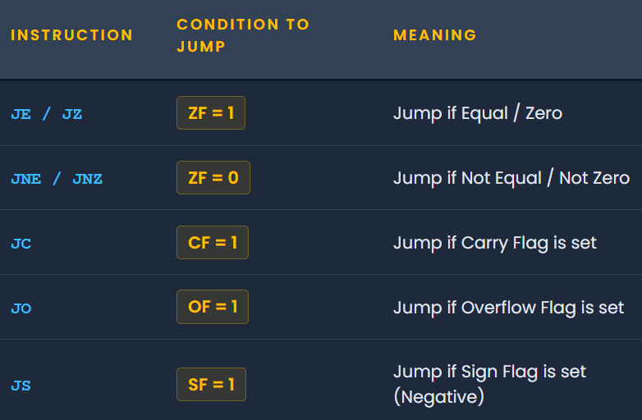

This means flags are the **decision engine** of the CPU

4.8 Flags in Reverse Engineering & Exploits **🔍**

When reversing:

* Watch flags after CMP
* Understand which jump depends on which flag
* Spot fake comparisons

Exploits may:

* Manipulate flags
* Abuse signed vs unsigned checks
* Bypass logic using CF vs OF confusion

Flags lie only if you misread them.

4.9 Summary: EFLAGS

The **EFLAGS** register is 32 bits wide and holds many independent flags.

These flags **report the results of operations** — for example, whether the last calculation produced zero, a negative value, or caused a carry/overflow. They also **control execution**, influencing things like conditional jumps or interrupts.

In short: **registers do the work**, and **flags decide what happens next**.

So, when it says “reports results,” it means EFLAGS tells the CPU what happened during the last instruction. For example:

* Zero Flag (ZF) → Was the result zero?
* Sign Flag (SF) → Was the result negative?
* Carry Flag (CF) → Did an arithmetic operation overflow?

These flags are what let instructions like JZ (jump if zero) or JC (jump if carry) know whether to take a branch.

4.10 Lock-In Questions

1. Why are CF and OF different?
2. Why does CMP not store a result?
3. Why is DF dangerous if left set?
4. How do debuggers use TF?

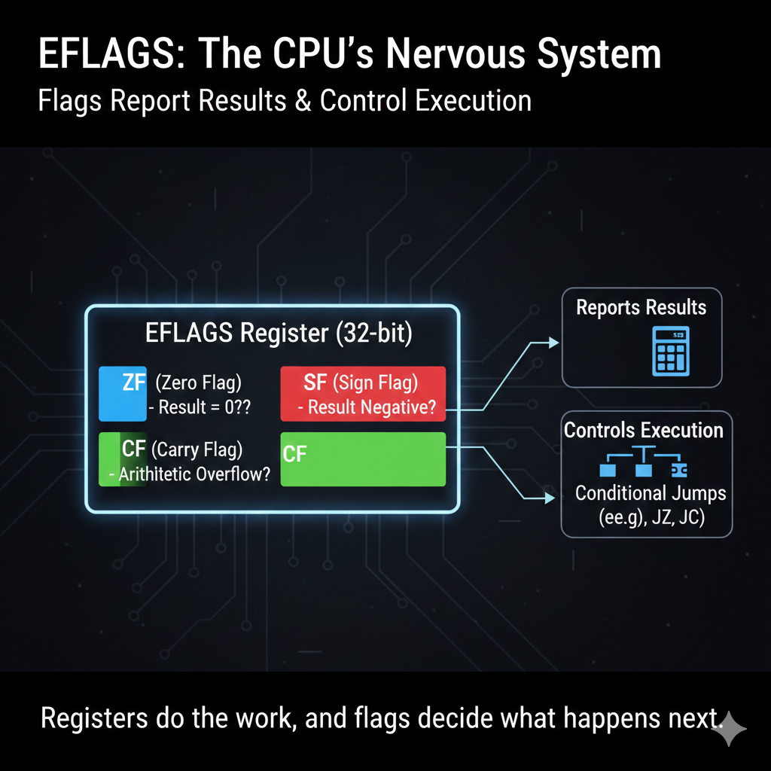

MMX, XMM, AND FPU REGISTERS (x86 SIMD & FLOATING POINT) **🧮⚙️**

5.1 First: Three Different Worlds (Do Not Mix Them)

Before details, lock this in:

There are **three related but distinct systems**:

1. **FPU (x87 Floating Point Unit)**
2. **MMX (Multimedia Extensions)**
3. **XMM (SSE / Streaming SIMD Extensions)**

They exist for different eras and purposes.

If you mix them mentally, debugging becomes hell.

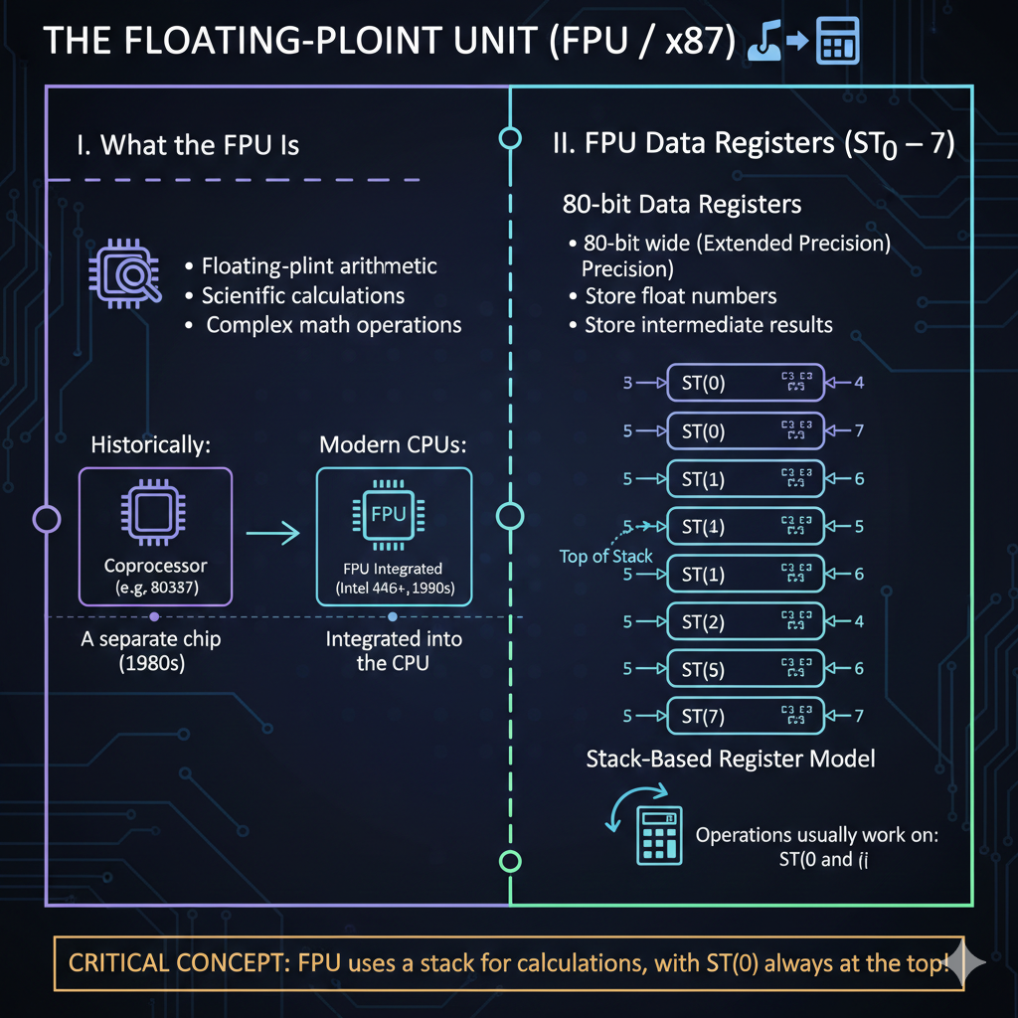

5.2 The Floating-Point Unit (FPU / x87) **🧮**

I. What the FPU Is

The **FPU** is the part of the CPU responsible for:

* Floating-point arithmetic
* Scientific calculations
* Complex math operations

Originally:

* It was a **separate chip** (coprocessor)
* Starting with **Intel 486**, it was integrated into the CPU

The 1980s, Intel 8086/8088 CPUs often used a separate Floating-Point Unit (FPU) chip, like the 8087. It was a real beast, handling all the floating-point calculations, freeing up the main CPU.

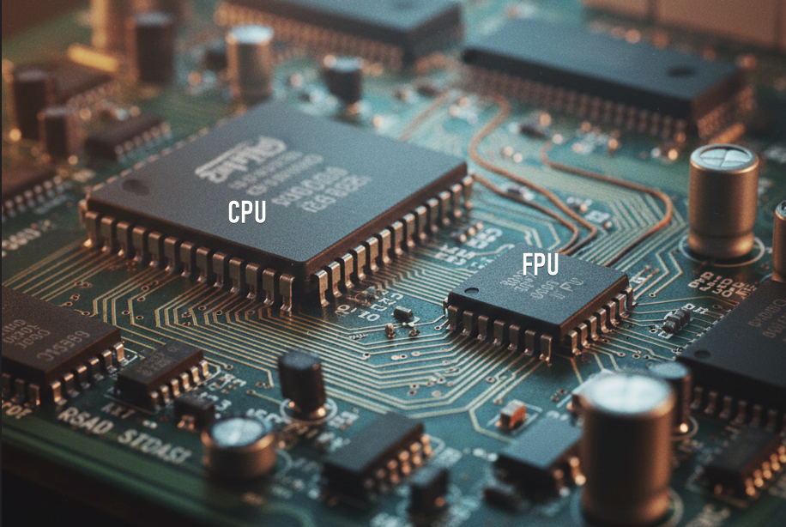

II. FPU Data Registers (ST0 – ST7)

The FPU has:

* **8 floating-point data registers**
* Named **ST(0) to ST(7)**
* Each register is **80 bits wide**

The FPU registers are where the CPU keeps floating-point numbers and intermediate results during calculations.

They’re special because they support **extended precision**, giving more accuracy than standard 32-bit or 64-bit floats.

One important idea is that the FPU works like a **stack**.

The top of the stack is always **ST(0)**, and most operations involve **ST(0)** along with another register somewhere deeper in the stack, like **ST(i)**.

This stack-based model is different from the general-purpose registers you’ve seen before, but once you get used to it, it makes managing floating-point calculations very efficient.

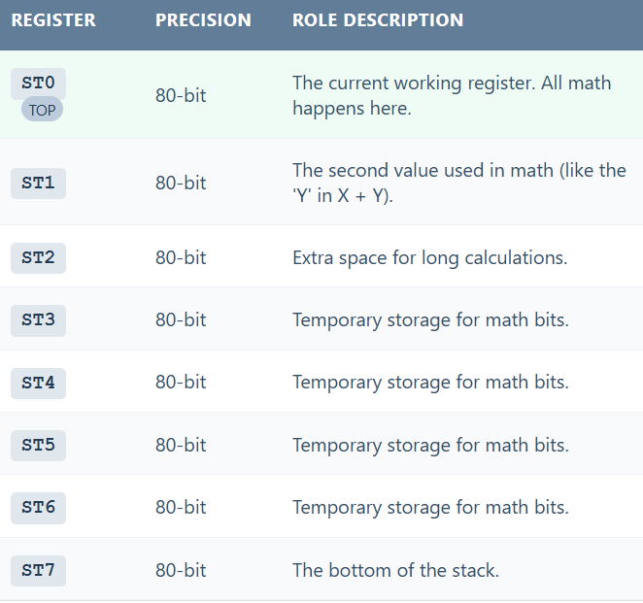

5.3 FPU Control & Status Registers (Often Ignored, Very Important)

The FPU does **not** only have data registers.

It also has **control and state registers**.

**FPU Control Register (16-bit)**

Controls:

* Precision
* Rounding mode
* Exception masking

**FPU Status Register (16-bit)**

Reports:

* Exceptions
* Condition codes
* Stack state

**FPU Tag Register (16-bit)**

Tracks:

* Which ST registers are empty
* Which contain valid data

These registers:

* Are critical for context switching
* Must be saved/restored by the OS

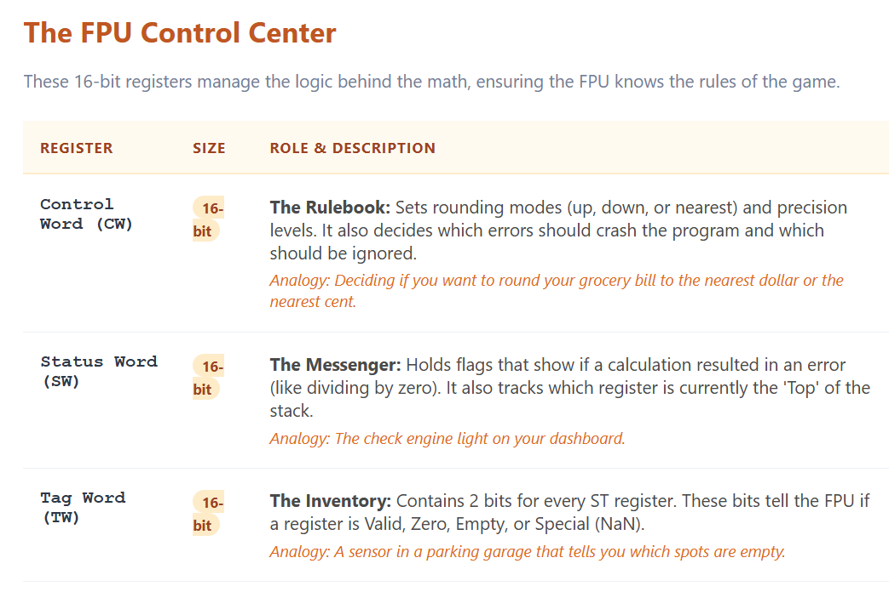

5.4 Opcode Register (FPU Opcode Register) **⚠️**

This is where the old notes get shaky — let’s fix it.

**What the Opcode Register Is**

* **16-bit register**
* Stores the opcode of the **last executed FPU instruction**
* **Read-only**
* Updated automatically by the processor

It is **part of the FPU state**, not general CPU execution.

It exists mainly for:

* Debugging
* Exception handling
* Error reporting

📌 It does **not** control execution  
📌 It does **not** replace EIP  
📌 It belongs to the **FPU subsystem**

5.5 FPU Pointer Registers (48-bit) **📍**

Now this part is critical and usually poorly explained.

**What “48-bit Pointer Registers” Means**

In **protected mode**, the FPU stores:

* **Instruction Pointer**
* **Data Pointer**

Each pointer is **48 bits**:

* 16-bit segment selector
* 32-bit offset

These registers point to:

* The instruction that caused an exception
* The memory operand used by the FPU

They help the OS:

* Recover from FPU faults
* Debug floating-point exceptions

📌 **Protected mode here means**:

CPU is using segmentation + protection  
Not real mode  
Not long mode

📌 **[HTML table for FPU instruction pointer and data pointer registers]**

5.6 MMX Registers (Legacy SIMD) **🎞️**

**What MMX Is**

MMX was introduced to speed up:

* Multimedia
* Image processing
* Audio/video workloads

MMX provides:

* **8 registers**
* Each **64 bits wide**
* Named MM0–MM7 (logically)

**Critical Truth ⚠️**

MMX registers are:

**Aliases of the FPU registers**

Meaning:

* MM0 uses the same physical storage as ST(0)
* MM1 ↔ ST(1)
* etc.

This causes a huge rule:

You **must clean the FPU state** after using MMX

Instruction used: EMMS

Failure to do this:

* Breaks floating-point operations
* Causes subtle bugs

This is why MMX is considered **legacy**.

5.7 XMM Registers (SSE / Modern SIMD) **🚀**

**What XMM Registers Are**

XMM registers were introduced to fix MMX’s problems.

They are:

* **Separate from the FPU**
* **Do not alias FPU registers**
* Designed for SIMD from day one

Properties:

* 8 XMM registers in 32-bit mode (XMM0–XMM7)
* Each **128 bits wide**

Used by:

* SSE
* SSE2
* SSE3
* Later extensions

They handle:

* Integers
* Floats
* Packed data

XMM registers are **the modern SIMD standard**.

📌 **[HTML table for XMM registers, size, purpose]**

5.8 Why XMM Replaced MMX

MMX problems:

* Aliases FPU registers
* Breaks floating-point code
* Requires EMMS cleanup
* Hard to context-switch safely

XMM advantages:

* Separate register file
* Cleaner design
* Better OS support
* Scales to AVX/YMM/ZMM later

This is why:

Modern compilers avoid MMX entirely

**X+5.9 Control Registers (CR0–CR3) – Fixing Old Mistakes 🔐**

Your old notes say:

“control registers are 16-bit”

❌ Incorrect.

**Correct Facts**

Control registers are:

* **32-bit in 32-bit mode**
* Named **CR0, CR2, CR3, CR4** (and CR8 later)

They control:

* Protected mode
* Paging
* Write protection
* Virtual memory

Access rules:

* **Read-only in user mode**
* **Read-write in supervisor (kernel) mode**

CR3:

* Holds page directory base
* Central to memory management

Control registers are **not FPU registers**.

5.10 Putting Everything in the Right Buckets **🧠**

**FPU Subsystem**

* ST0–ST7 (80-bit)
* Control register
* Status register
* Tag register
* Opcode register
* Instruction pointer (48-bit)
* Data pointer (48-bit)

**MMX Subsystem**

* MM0–MM7 (aliases of FPU)

**SIMD Subsystem (SSE)**

* XMM0–XMM7 (128-bit, separate)

**System Control**

* CR0–CR4 (privileged)

5.11 Why This Chapter Is Critical

If you don’t understand this:

* Context switching makes no sense
* Floating-point crashes look random
* SIMD bugs feel supernatural
* OS internals feel impossible

This chapter explains:

* Why EMMS exists
* Why SSE replaced MMX
* Why OSes save FPU state
* Why exploits care about FPU context

5.12 Lock-In Questions

1. Why do MMX registers break floating-point code?
2. Why are FPU registers 80-bit instead of 64-bit?
3. Why are FPU pointers 48-bit in protected mode?
4. Why did SSE need separate registers?